Assignment 7.2 - WhatABook

TECHNICAL DESIGN DOCUMENT

|  |  |
| --- | --- |
| **Author** | Michael Christman & Jennifer Hoitenga |
| **Last Updated** | 7/22/2023 5:20 AM |
| **Version Number** | 1 |

**Version History**

|  |  |  |  |
| --- | --- | --- | --- |
| Name | Date | Reason for Change | Version |
| *Krasso, Richard* | *10/17/2019* | *New document format* | *3.0.0* |
|  |  |  |  |
|  |  |  |  |
|  |  |  |  |
|  |  |  |  |
|  |  |  |  |
|  |  |  |  |
|  |  |  |  |
|  |  |  |  |
|  |  |  |  |

Table of Contents

SECTION 1: INTRODUCTION 3

1.1. Purpose 4

1.2. Terminology 6

1.3. User Personas 6

1.4. User Stories 10

1.5. Time Estimations 11

SECTION 2: PROCESS DESIGN 13

2.1. Prototypes 13

2.2. ORD (Object Relational Diagram(s)) 16

2.3. NoSQL Document Diagram 17

2.4. NoSQL Data Structure 17

SECTION 3: QA TESTING 19

3.1. QA Test Plan 19

3.2. Unit Tests 19

SECTION 4: REFERENCES 24

# SECTION 1: INTRODUCTION

Introducing "The Slytherin Serpents," a formidable and ambitious team commanded by the resourceful, determined Team Captain, Michael Christman. As prideful members of House Slytherin, our team revels in the character traits of sagacity, ingenuity, and adaptability, and the members of our house have chosen the menacing basilisk as our fearsome mascot. The basilisk, a mythical creature that is frequently referred by the moniker “the king of serpents”, embodies the core ideals of Slytherin. Analogous to the serpent, we are malleable, tactical, and resolute in the face of adversity. Our team's name symbolizes our unwavering pride in belonging to Slytherin, while our mascot, the basilisk, enhances our identity with a sense of prestige and authority. Together, we embrace our heritage and are prepared to conquer any obstacles that await in our path, leaving a legacy deserving of the Slytherin name.

Meet the Members of the Slytherin Serpents Team:

 Michael Christman was born in Kenosha, WI on November 1st, 1999. He lives at home with his parents and younger brother, Sean. Michael and Sean are currently attending Bellevue University. Michael is pursuing his bachelor's degree in web development and Sean is pursuing a degree in software development.

Michael aspires to be a front-end web developer with 5 years of experience building dynamic and responsive websites. While the projects on his resume are relatively limited, he strives to deliver applications that fulfill clients' expectations.

He is proficient in a variety of programming languages, including HTML, CSS, JS, and Python. He also possesses an intermediate level of knowledge with database concepts. His effective problem-solving and communication skills are qualities that can make him a vital asset to a web development team.

One of Michael's great strengths is his collaboration with groups to ensure project requirements and user demands are adhered to. He is an effective communicator, always considering the client's demands a top priority.

Michael was diagnosed on the autism spectrum at a young age. Along with his web design qualifications, Michael's neurodivergence grants him a different perspective on several facets of life. He is a creative, unique thinker that’s always looking for fresh, innovative ideas to address certain challenges. He is devoted to staying up-to-date on recent trends, events, and advancements in the I.T. industry.

He is a cinephile who loves watching movies and T.V. shows. Michael's other hobbies include video games, reading, and creating websites. Overall, Michael is a skilled web developer devoted to providing satisfying results. His aspirations combined with his technical knowledge, imagination, and enthusiasm to learn make him an ideal team member for collaborative web projects.

Jennifer Hoitenga is currently a student pursuing a bachelor's degree in Web Development. She has worked at a pediatric hospital for over 20 years, starting in the Health Information Management department in 2001 and later transitioning to the Information Systems department in 2008. In 2013, Jennifer accepted a database administrator role, which subsequently expanded to include custom programming involving JavaScript, PHP, and APIs. In late 2022, she enrolled at Bellevue University to further her education in Web Development by pursuing a bachelor's degree.

During her leisure time, Jennifer enjoys spending quality time with her beloved pets, Georgia and Olive (dogs), as well as her cat named Lenny. She has a passion for gardening, embarking on road trips, camping, fishing, playing video games, and exploring antique stores. Jennifer takes pleasure in discovering unique vintage items and delving into the history behind each find. Additionally, she is an avid fan of Leonard Nimoy and the original Star Trek series.

## Purpose

WhatABook is a small, used book store that would like to develop a website with the following goals:

**Goals of the website:**

1. Browse in-store book listings: The website should provide customers with the ability to explore the available books in the physical store. This feature allows users to view the books' details, such as title, author, genre, and bookId.
2. Wishlist functionality: Customers should be able to add books they are interested into a wishlist. This feature allows users to save books they wish to purchase or revisit later.
3. View wishlist: The application should provide a dedicated section where customers can easily access and view their wishlist. This allows users to keep track of the books they have added for future reference.
4. Genre-based book listing: The application should offer a categorized listing of books by genre. This allows users to browse books based on their preferred genres, making it easier to find books of interest.
5. Author-based book listing: The application should provide a listing of books organized by author. This feature allows users to explore books written by specific authors they may be interested in.
6. Title search: The application should enable customers to search for books based on their titles. This feature allows users to quickly locate specific books they are looking for.
7. BookId search: The application should allow users to search for books using their unique bookId. This feature provides a direct and precise way for users to find books based on their specific identifiers.
8. Simplistic user interface: The application's interface should be designed to be user-friendly and straightforward, catering to middle-aged users with limited computer experience. The goal is to make it easy for customers to navigate the application and access its features without confusion or complications.

**Core Users:**

1. Patrons: These are the primary users of the website. They are individuals who visit WhatABook's physical store and are interested in browsing and purchasing books. The website aims to cater to middle-aged customers with minimal computer experience.
2. Avid readers/literature enthusiasts: These users have a passion for reading and are interested in exploring a wide range of books across different genres and authors. They may use the website to discover new books, create wishlists, and stay updated on the latest offerings from WhatABook.
3. Regular patrons: These users have already made purchases from WhatABook's physical store or have engaged with the store in some way. They may use the website to manage their wishlists, view their purchase history, or search for specific books.
4. College/school students: These customers are students currently attending an academic institution. They may use the website to purchase or rent textbooks for a specific course they are taking during a certain semester.
5. Gift shoppers: These users are looking for books to purchase as gifts for friends, family, or colleagues. The website can assist them in browsing through different genres, authors, and book listings to find suitable gifts.
6. Bibliophiles/book collectors: These users are avid book collectors who are interested in finding specific editions, rare books, or books by specific authors. They may use the website to search for books using the bookId feature or to explore books by a particular author.
7. Teachers: These customers are instructors teaching at an academic institution. They may use the website to purchase or rent textbooks relevant to the course(s) they are teaching.

## Terminology

|  |  |
| --- | --- |
| **Name** | **Comments** |
| *MEAN Stack* | *MongoDB, Express, Angular, and Node.js* |
| *VS Code* | *Development IDE* |
| *SoapUI* | *API testing tool* |
| *MongoDB Compass* | *Database development IDE* |
| *Angular Material* | [*https://material.angular.io/*](https://material.angular.io/) |
| *Flex-layout* | [*https://github.com/angular/flex-layout*](https://github.com/angular/flex-layout) |

## User Personas

|  |
| --- |
| **Persona:** Book Enthusiast  **Name:** Maya Patel  **Age:** 49  **Status:** Married  **Occupation:** Middle School Teacher  **Education Level:** Bachelor’s Degree  **Annual Income:** $60,000  **Computer Skill Level:** Basic computer skills  **Favorite Apps:** Facebook  **Goals:** Maya loves to read and is always looking for new and interesting titles. She enjoys browsing through bookshelves and wants to replicate that experience online. She would also like to create a wishlist of books that she would like to read but does not have the time or the immediate budget to do so. Maya will prefer a simple and intuitive user interface as she is not very tech-savvy.  **Challenges:** May feel overwhelmed or confused if the website is overly complicated or lacks clear instructions. May get frustrated if she cannot find books by her favorite authors. Would be motivated to use website if it offers a user-friendly experience that allows her to discover new books, manage her wishlist and find books by her favorite authors easily.  **Features used most often:** Browsing through book listings, creating a wishlist, searching by title. |

|  |
| --- |
| **Persona:** Budget-Conscious Reader  **Name:** Mark Miller  **Age:** 66  **Status:** Divorced  **Occupation:** Retired accountant  **Education Level:** Master’s Degree  **Annual Income:** $50,000  **Computer Skill Level:** Basic computer skills  **Favorite Apps:** None  **Goals:** Mark enjoys exploring books across different genres and looks for an easy way to discover books from various genres he may find interesting. He also likes to look for bargains likes to find books that offer good value for his money and he likes to stay within a specific budget while purchasing books. He makes informed purchasing decisions based on pricing considerations and wants to find a straightforward and hassle-free process to purchase books directly from the website. He prefers minimal steps and a secure payment system.  **Challenges:** May feel overwhelmed or confused by complex features or technical jargon. Would be motivated to use website if it offers a user-friendly experience that allows him to explore books easily, ability to sort by price, identify discounts or promotions and price comparisons.  **Features used most often:** Browse books by genre, user-friendly design, price sorting, easy checkout process. |

|  |
| --- |
| **Persona:** Book Lover  **Name:** Emma Nguyen  **Age:** 29  **Status:**Single  **Occupation:**Marketing Executive  **Education Level:**Master’s Degree  **Annual Income:** $70,000  **Computer Skill Level:**Intermediate computer skills  **Favorite Apps:**Instagram, Tik Tok, Facebook  **Goals:**Emma loves to discover new books across different genres and likes to keep track of her reading progress and create a reading list. She also likes to access book recommendations, connect with book enthusiasts and participate in book discussions.  **Challenges:** If the browsing experience is not well-organized, this may overwhelm her. May find it challenging to manage her extensive wishlist and make decisions on what to read next.  **Features used most often:**Browse books by genre, create a wishlist, book search |

## User Stories

|  |  |  |
| --- | --- | --- |
| **Persona 1 – Maya Patel** | | |
| **Story** | **Story Points** | **Rank** |
| As a book enthusiast, I want to create a wishlist of books I'm interested in reading so that I can keep track of them for future reference. | 2 | 1 |
| As a book enthusiast, I want a simplistic and user-friendly interface that provides clear instructions and avoids technical jargon, enabling me to easily navigate and use the website. | 1 | 2 |
| As a book enthusiast, I want to browse through the in-store book listings by genre so that I can explore books that align with my reading preferences. | 3 | 3 |
| As a book enthusiast, I want to view books by my favorite authors, so that I can stay updated with their latest releases. | 5 | 5 |
| As a book enthusiast, I want to search for books by their titles, allowing me to quickly locate specific books I'm looking for. | 8 | 8 |
| Total: | 19 | 19 |

|  |  |  |
| --- | --- | --- |
| **Persona 2 – Mark Miller** | | |
| **Story** | **Story Points** | **Rank** |
| As a budget-conscious reader, I want to browse books by genre so that I can explore a variety of books that match my interests. | 3 | 3 |
| As a budget-conscious reader, I want to sort search results by price range, so I can find books within my budget. | 3 | 5 |
| As a budget-conscious reader, I want a user-friendly design and easy navigation to quickly find the books I'm interested in. | 8 | 8 |
| As a budget-conscious reader, I want a simple and straightforward book purchase process so that I can easily buy the books I want. | 2 | 2 |
| As a budget-conscious reader, I want to explore the sale or discounted books section, so I can discover books at reduced prices. | 2 | 3 |
| Total: | 18 | 21 |

|  |  |  |
| --- | --- | --- |
| **Persona 3 – Emma Nguyen** | | |
| **Story** | **Story Points** | **Rank** |
| As a book lover, I want to browse the bookstore's collection by genre, so I can discover new books to read. | 5 | 8 |
| As a book lover, I want to create a wishlist of books that I'm interested in, so I can keep track of books I want to read or purchase. | 3 | 5 |
| As a book lover, I want to search for books by their title or book ID, so I can find specific books quickly and easily. | 2 | 3 |
| As a book lover, I want to view and manage my wishlist, so I can prioritize my reading or purchasing decisions. | 3 | 5 |
| As a book lover, I want to see a curated list of recommended books based on my reading history or preferences, so I can discover personalized book suggestions. | 5 | 8 |
| Total: | 18 | 29 |

## Time Estimations

|  |  |  |  |  |
| --- | --- | --- | --- | --- |
| **Persona 1 – Maya Patel** | | | | |
| **Story** | **Story Points** | | **Time (days)** | |
| As a book enthusiast, I want to create a wishlist of books I'm interested in reading, so that I can keep track of them for future reference. | 2 | | 2 | |
| As a book enthusiast, I want a simplistic and user-friendly interface that provides clear instructions and avoids technical jargon, enabling me to easily navigate and use the website. | 1 | | 1 | |
| As a book enthusiast, I want to browse through the in-store book listings by genre so that I can explore books that align with my reading preferences. | 3 | | 3 | |
| As a book enthusiast, I want to view books by my favorite authors, so that I can stay updated with their latest releases. | 5 | | 5 | |
| As a book enthusiast, I want to search for books by their titles, allowing me to quickly locate specific books I'm looking for. | 8 | | 8 | |
| Totals: | 19 | | 19 | |
|  | | | |
| **Persona 2 – Mark Miller** | | | |
| **Story** | **Story Points** | **Time (days)** | |
| As a budget-conscious reader, I want to browse books by genre so that I can explore a variety of books that match my interests. | 3 | 3 | |
| As a budget-conscious reader, I want to filter search results by price range, so I can find books within my budget. | 3 | 3 | |
| As a budget-conscious reader, I want a user-friendly design and easy navigation to quickly find the books I'm interested in. | 8 | 8 | |
| As a budget-conscious reader, I want a simple and straightforward book purchase process so that I can easily buy the books I want. | 2 | 2 | |
| As a budget-conscious reader, I want to explore the sale or discounted books section, so I can discover books at reduced prices. | 2 | 2 | |
| Total: | 18 | 18 | |

|  |  |  |
| --- | --- | --- |
| **Persona 3 – Emma Nguyen** | | |
| **Story** | **Story Points** | **Time (days)** |
| As a book lover, I want to browse the bookstore's collection by genre, so I can discover new books to read. | 5 | 5 |
| As a book lover, I want to create a wishlist of books that I'm interested in, so I can keep track of books I want to read or purchase. | 3 | 3 |
| As a book lover, I want to search for books by their title or book ID, so I can find specific books quickly and easily. | 2 | 2 |
| As a book lover, I want to view and manage my wishlist, so I can prioritize my reading or purchasing decisions. | 3 | 3 |
| As a book lover, I want to see a curated list of recommended books based on my reading history or preferences, so I can discover personalized book suggestions. | 5 | 5 |
| Total: | 18 | 18 |

# SECTION 2: PROCESS DESIGN

## 2.1. Prototypes

Prototype link: <https://marvelapp.com/whiteboard/vmX7VXncHPsUXEHbUqXq>

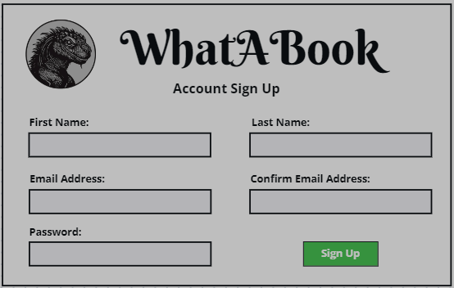

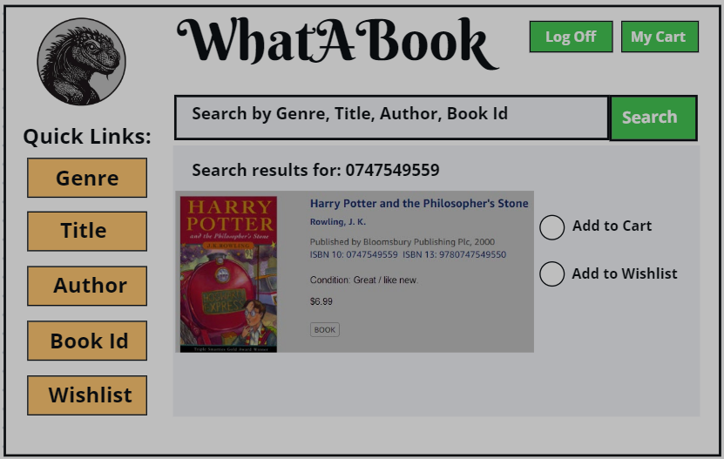

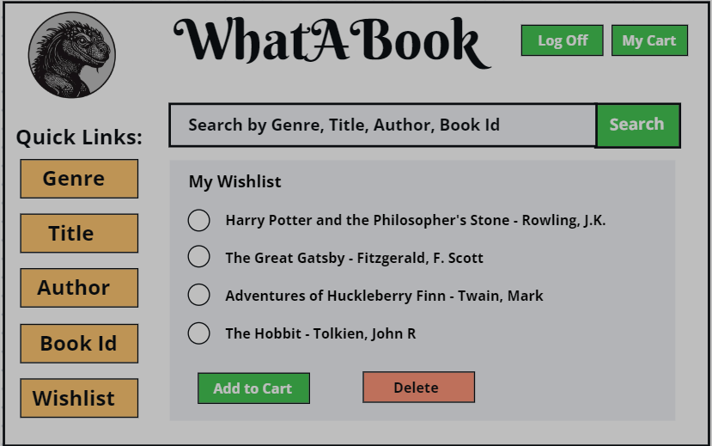

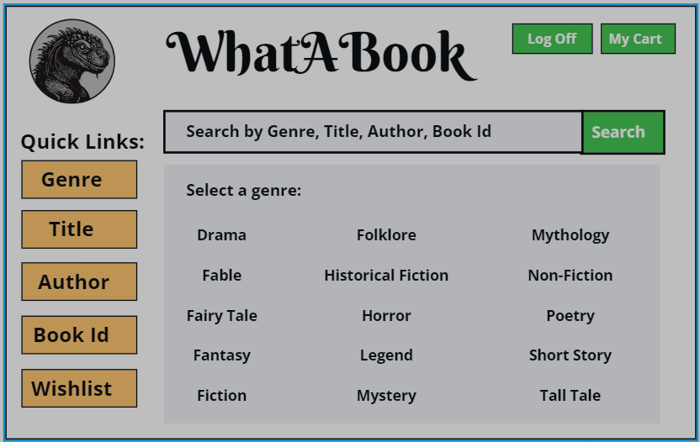

## 2.2. ORD (Object Relational Diagram(s))

## 2.3. NoSQL Document Diagram

|  |  |  |  |  |
| --- | --- | --- | --- | --- |
| **BOOK(s)** | **bookId** | **title** | **genre** | **author** |
| 0747549559 | Harry Potter and the Philosopher’s Stone | Fantasy | J. K. Rowling |
| 0486282112 | Frankenstein | Horror | Mary Shelley |
| 1957635002 | Haunting Adeline | Romance | H. D. Carlton |
| 0399501487 | Lord of the Flies | Fiction | William Golding |
| 0670813028 | Stephen King’s It | Horror | Stephen King |
| 0553381687 | A Game of Thrones | Fantasy | George R.R. Martin |
| **CUSTOMER(s)** | **customerId** | **firstName** | **lastName** |  |
| c1005 | Emma | Nguyen |  |
| **WISHLIST** | **customerId** | **bookId** |  |  |
| c1005 | ['0399501487', '0486282112', '1957635002'] | | |

## 2.4. NoSQL Data Structure

{

  "books": [

    {

      "bookId": "0747532745",

      "title": "Harry Potter and the Philosopher's Stone",

      "genre": "Fantasy",

      "author": "J. K. Rowling"

    },

    {

      "bookId": "0486282112",

      "title": "Frankenstein",

      "genre": "Horror",

      "author": "Mary Shelley"

    },

    {

      "bookId": "1957635002",

      "title": "Haunting Adeline",

      "genre": "Romance",

      "author": "H. D. Carlton"

    },

    {

      "bookId": "0399501487",

      "title": "Lord of the Flies",

      "genre": "Fiction",

      "author": "William Golding"

    },

    {

      "bookId": "0670813028",

      "title": "Stephen King’s IT",

      "genre": "Horror",

      "author": "Stephen King"

    },

    {

      "bookId": "0553381687",

      "title": "A Game of Thrones",

      "genre": "Fantasy",

      "author": "George R.R. Martin"

    }

  ],

  "customers": [

    {

      "customerId": "c1005",

      "firstName": "Emma",

      "lastName": "Nguyen"

    }

  ],

  "wishlist": [

    {

      "customerId": "c1005",

      "bookId": ["0399501487", "0486282112", "1957635002"]

    }

  ]

}

# SECTION 3: QA TESTING

## 3.1. QA Test Plan

* Verify customers can be created, updated and deleted.
* Verify books can be created, updated and deleted.
* Verify wishlist items can be added, retrieved and removed.
* Validate required fields are enforced.
* Test search functionality to ensure you can locate by customer id, book id, book title, author, genre, etc.
* Test error handling when customer id not found in python console application.

## 3.2. Unit Tests

Loading the script.js file.

Displaying a list of books.

Displaying a list of books by genre.

Displaying a list of books by author.

Displaying a list of books by bookId.

Displaying a wishlist by customerId.

Adding a book to a customer’s wishlist.

Removing a book from a customer’s wishlist.

Connecting to MongoDB.

Displaying a list of all books.

Displaying a list of genres with a prompt for user.

Displaying a list of books by selected genre.

Displaying a prompt for customer’s id to view wishlist:



If customer exists, display customer’s name and book titles from wishlist.

An error message is shown if customer does not exist.

Validating required fields are enforced.

Confirmed documents were inserted into the correct collections.

# SECTION 4: REFERENCES

Add colour to text in Python | Kaggle. (n.d.). Kaggle: Your Machine Learning and Data Science Community. <https://www.kaggle.com/discussions/general/273188>

Data model design — MongoDB manual. (n.d.). MongoDB: The Developer Data Platform | MongoDB. <https://www.mongodb.com/docs/manual/core/data-model-design/>

Programming with Mosh. (n.d.). Python for Beginners - Learn Python in 1 Hour [Video]. YouTube. <https://www.youtube.com/watch?v=kqtD5dpn9C8>

Unsplash. (n.d.). Beautiful Free Images & Pictures | Unsplash. <https://unsplash.com/>